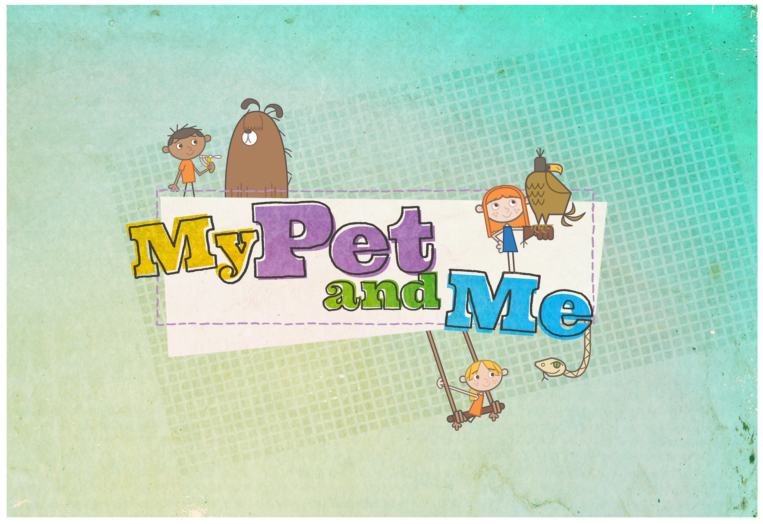
MY PET AND ME SERIES 3 APPLICATION FORM:
Please fill in all sections and give us as much information as possible. Use an extra page if you need to.
Childs Full Name:

Childs Nickname:
(If they have one):

Childs D.O.B:

Type of Pet (s) / Breed / Age of animal:

Tell us a little bit about the pet. For example where it lives, habits etc.

What does the child do to help care for the pet?

What makes the relationship between the pet and child unique?

Is there anything special that the child and pet do together. For example, animal socialisation classes or gymkhana etc.?

Your Name:

Your Relationship to the Child:

Your Contact Number (Both Home & Mobile):

Your Email Address:

Your Postal Code:

How did you initially hear about our search for applicants?

*Please either upload, scan in or send a hard copy picture of the child and pet as part of your application (we will not be able to return any hard copy photos) *
Thank you for taking the time to fill out this application form. Please either email it to us at mypetandme@bbc.co.uk or post it to the address below:

My Pet and Me Production Team
BBC Scotland
Zone 4.34
40 Pacific Quay
Glasgow
G51 1DA

The closing date for all applications is Friday 18th March 2016. Please note that we cannot guarantee that you will be contacted after submitting an application. If we need any more information or would like to progress your application further, then a member of our team will be in touch before the end of April 2016. Thank you and good luck!

